Pure Component Issues ->

Output Screen before any changes->

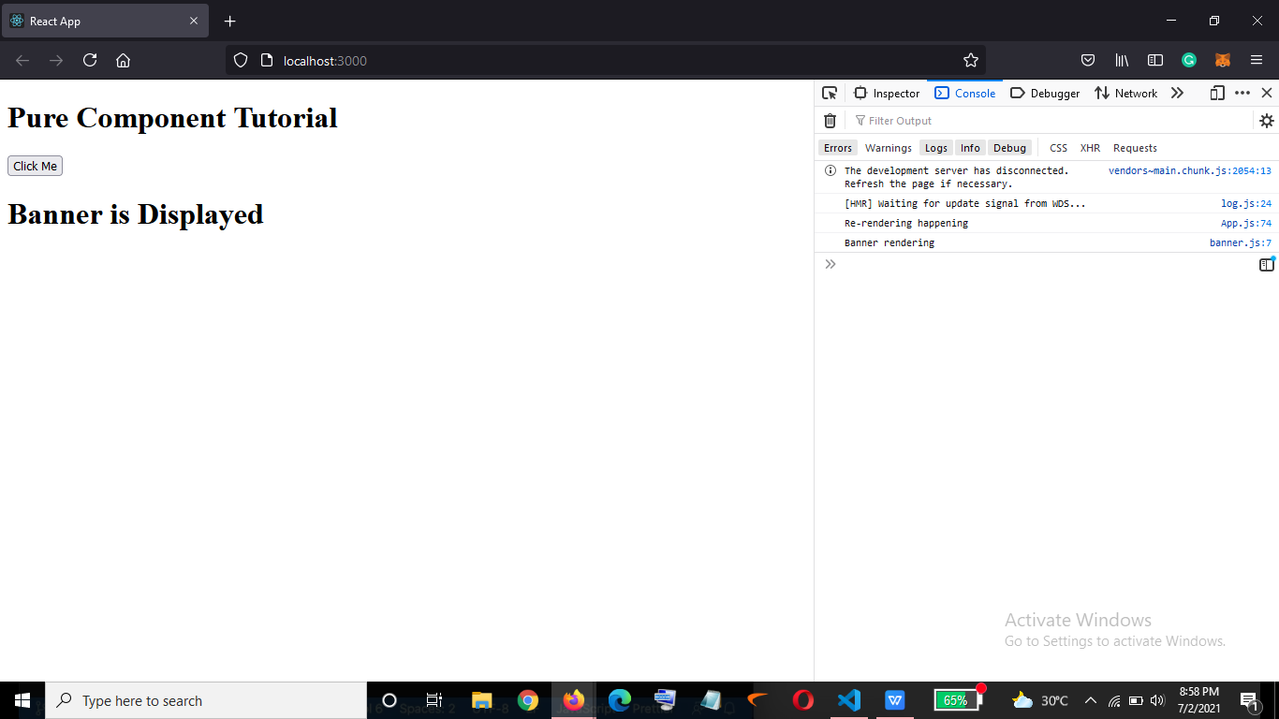

Now when I will have an array and on the click on the button I want the array to get updated->

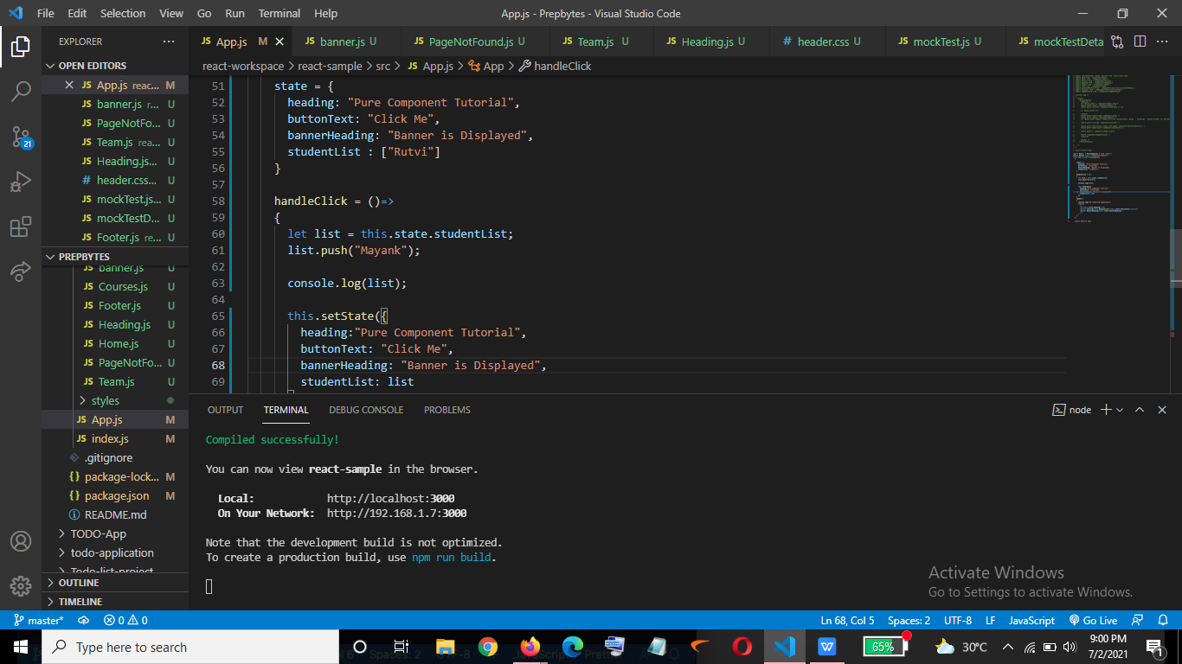

Output->

Now as we can see another element has been pushed to the array and still the render method is not been called..

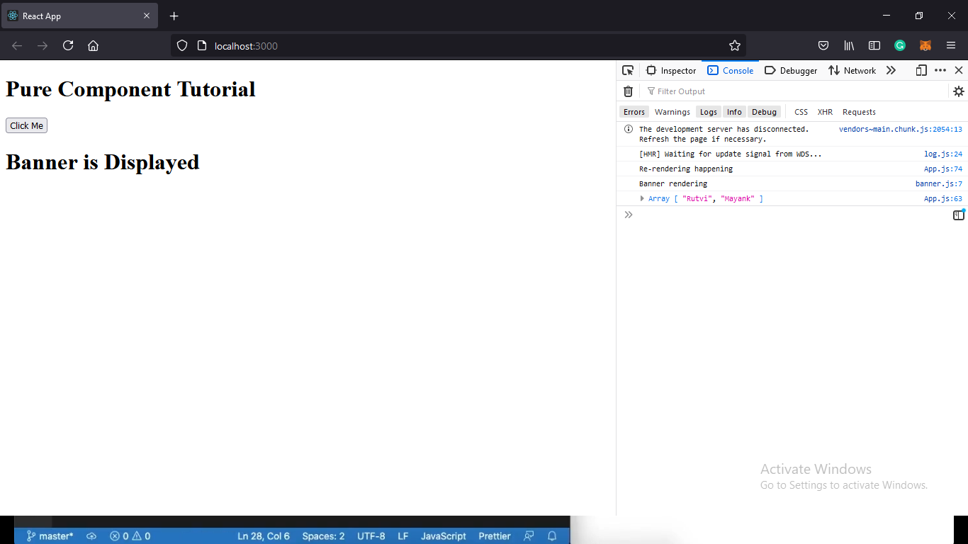

Let’s see the issue while using objects->

I created an object with property email ->

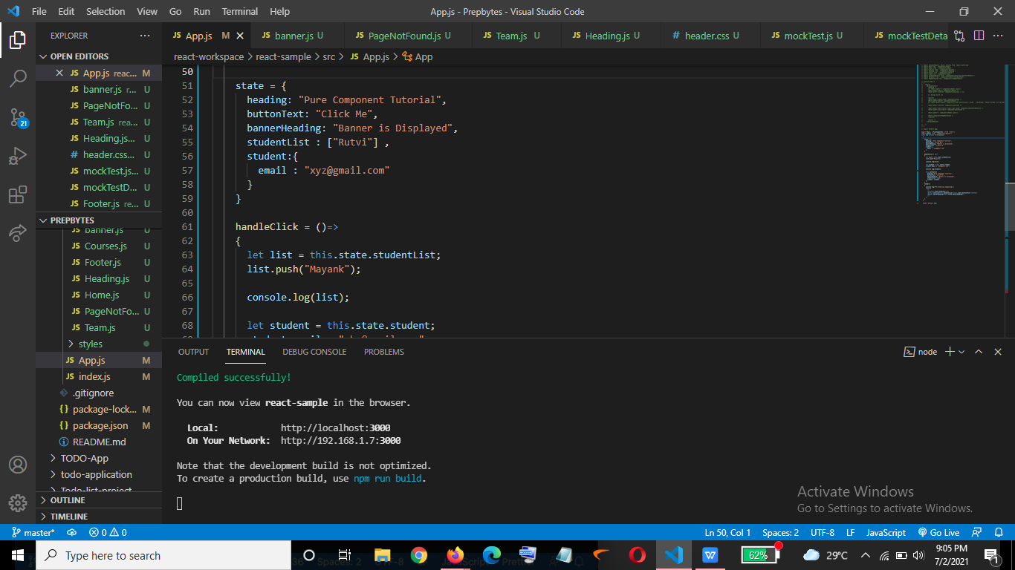

And on the click of the button I want the email to get updated->

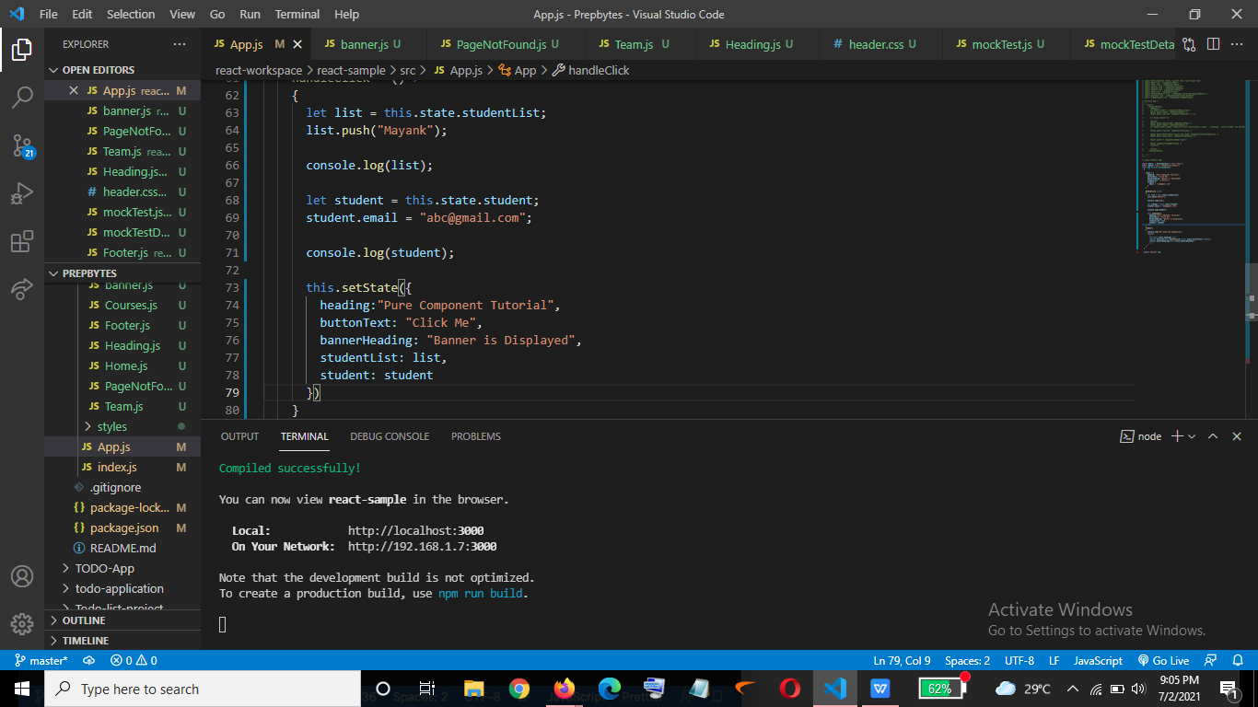

Output-> AS we can see values have been updated but the render function is not called.

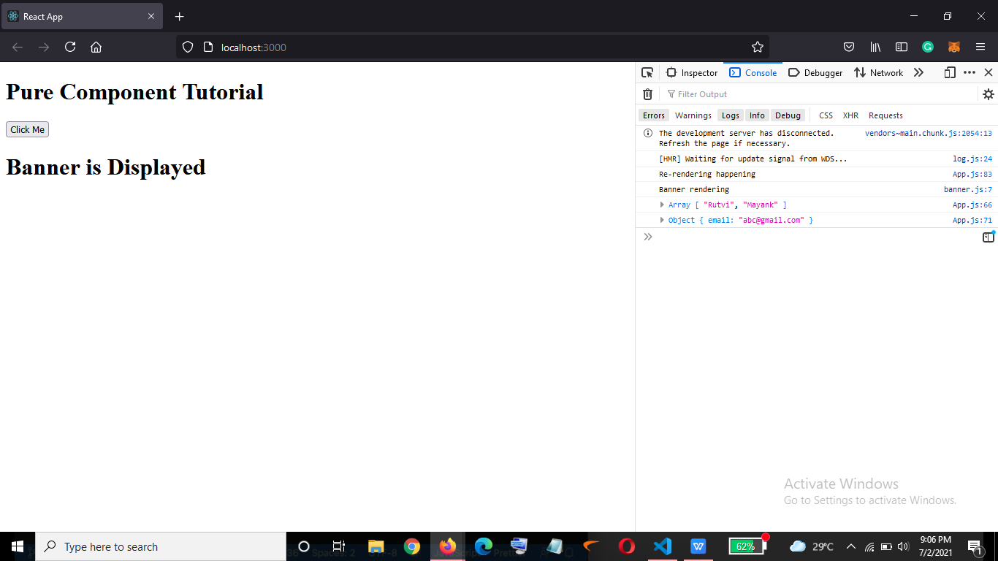

In order to call the render function in Pure Components while making use of objects we will have to give reference to an entirely new object ->

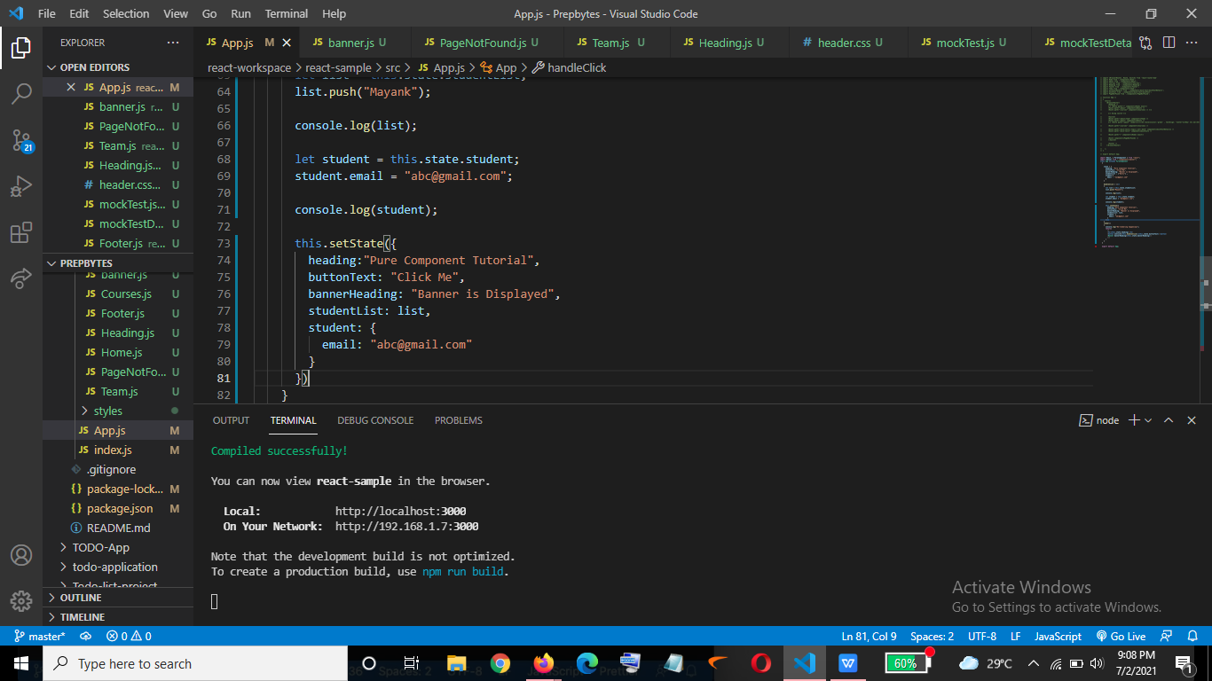

Output-> Now we see re-rendering happening

